CREATIVE BRIEF
Project Owner: Kat Chaves
Assigned to: Rob Arce / Andy Hine
Brand: VRB Marketing
Date assigned: 02/09/2012
Item: integration of new brands into affiliate platform

JOIN FORM
- Add an additional section at the bottom of the join form (prior to security code box) which allows clients to opt in to brands. Selection of at least one brand is required to complete the form. Allow for selection of multiple brands. Use checking boxes option for selection.
Content: Please select the brand (s) you would like to partner with:
WagerWeb.com / SportsBettingOnline.com (SBO) / Inspin.com /

HOME (logged in)
- Profile Info

This section will need to be modified to add info relating to each brand. A small box for each item will be needed. Example below:

AFFILIATE ID
WagerWeb.com | AFxxxxxxx
InSpin.com | AFxxxxxxx
SBO.com | AFxxxxxxx

COMMISSION RATE
WagerWeb.com | 25%
InSpin.com | 30%
SBO.com | 35%

BALANCE
WagerWeb.com | $XXXXX
InSpin.com | $XXXXX
SBO.com | $XXXXX
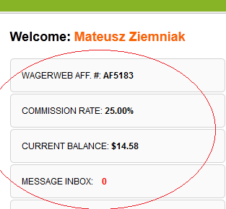

- Weekly Quick Stats

Affiliatesite.com | Impressions | Clicks | New Sign Ups | Net | Commission
WagerWeb.com
InSpin.com
SBO.com
Anothersite.com | Impressions | Clicks | New Sign Ups | Net | Commission
WagerWeb.com
InSpin.com
SBO.com

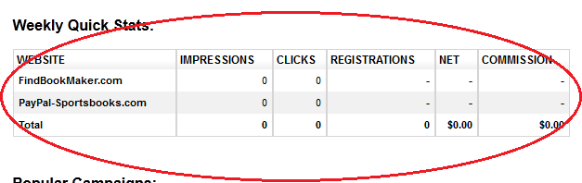

- Popular Campaigns – banners displayed should only relate to the brands the affiliate is tagged to.

MARKETING TOOLS
- Add all brands to the “Select a Brand” drop down menu.
- Fix functionality of drop down menu for “Select Marketing tool”. Tools should be tagged to their respective product. Example – if Casino product was selected, then the Live Odds widgets should not appear in the drop down list.
- All internal pages should have a “back” button in the upper right hand corner. (having it on the left hand side loses visibility)
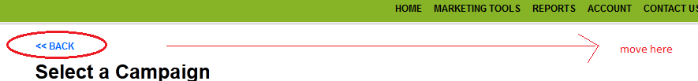

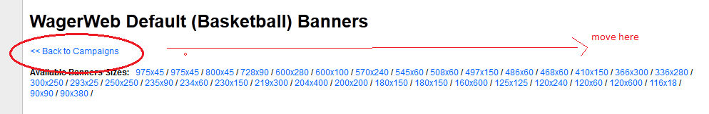

- Banner Campaign > campaign list should allow modifying the order of campaigns by their priority. (seasonal, special promos, etc.) Unless otherwise specified, the “default campaign” should always be the first in the list.

REPORTS
- Contain report name / description to the left hand side. Remove link to report.
- Add a section on the right hand that contains drop down menus to select brand and report.
Content:
Step. 1. Select Brand (WagerWeb.com / SBO.com / InSpin.com)
Step 2. Select Report ( Marketing Report, Commissions, Daily Figures, Player Report, Payment Statement, Conversion Report, Player Deposits)

ACCOUNT
- Payout Request. Content will need to vary by the options available for SBO.com and Inspin.com. (pending)

